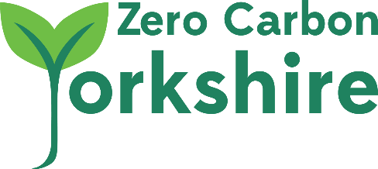

Community Facilitators Application Form

If you are interested in becoming a voluntary Community Facilitator and willing to attend the 2 day training course at CAT on 1st and 2nd May, please fill in the form below. ZCY will pay for the course fees and accommodation and consider contributing to travel costs depending on your means.
In return we will provide mentoring support, guidance and resources to help you start low carbon initiatives in your area.

First Name ____________________Last Name___________________________________

Email ___________________________________ Mobile No.____________________

Address_______________________________________________Postcode______________
In which area(s) would you be prepared to do this work (e.g. where I live only, neighbourhoods in the Huddersfield area, anywhere in Yorkshire)

How many days voluntary work can you offer in 2019
Please provide information about your relevant skills, knowledge and experience.
Please state why you are interested in this opportunity

I agree to attend the course and carry out the voluntary work above
I would like a contribution towards my travel costs
Signature
Print or sign name
Zero Carbon Yorkshire is a limited company registered in England and Wales No. 10575524
Registered Address: 25 Hollin Lane Leeds LS16 5NB

